Newspaper Genres

A (Heavily intellectual, highly serious) – BROADSHEET/QUALITY
The Guardian - Centre Left (Labour, some Lib Dem)
The Independent (online only) - Centre Left (Labour and Lib Dem)
The Observer - Centre Left (Labour and Lib Dem)
The Financial Times - Centrist (Mixed)
The Times – Centrist/ Right (Mixed/Conservative)
The Telegraph - Centre Right (Conservative)

B (Intellectual and serious, but cut down for the convenience of the reader without much time on his or her hands) – BROADSHEET/QUALITY
The i - Centre Left (Labour and Lib Dem)
The Morning Star - Left (Socialist parties, some Labour)

C (Non-intellectual, sensationalist, often derided by readers of A and B papers) – TABLOID/POPULAR
Mirror - Centre Left (Labour)
Express - Right (Conservative, UKIP)
Mail - Right (Conservative, UKIP)

D (Very non-intellectual, hugely sensationalist and barely qualify as newspapers at all) – TABLOID/POPULAR
Sun - Right (Conservative)
Star - Right (Conservative and far right parties)

Tabloid | Broadsheet
- Popular press  - Advertising aimed at lower social groupings (C2,D & E)  - Bold layout (eg colour on the masthead, very bold typeface, easy to read), with large, dramatic pictures  - Language is informal, colloquial  - Shorter articles, more pictures, less 'in-depth' reporting  - Puns and jokes in headlines  - More focus on human interest stories, celebrity gossip  - Use of gimmicks such as bingo games, free travel tickets, online surveys to attract readers | - 'Quality' or 'serious' press  - Advertising aimed at higher social groupings (A,B,C1)  - More sophisticated and formal language used in articles  - Plainer layout (no colour on the frontpage, smaller typeface suggests readers will make more effort to read it), and subtle, possibly smaller, pictures  - Longer articles, more detailed  - Serious headlines  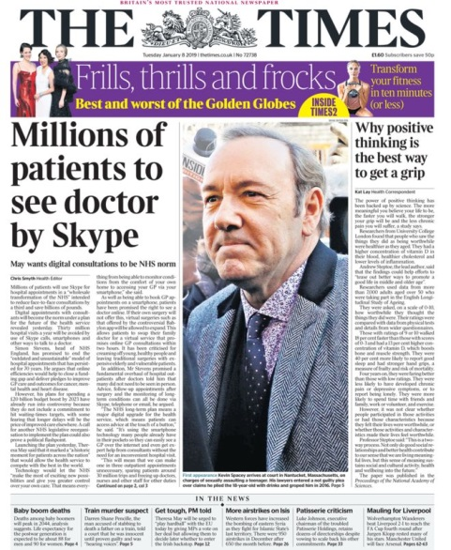  - More focus on politics, international news, reviews of "high" culture e.g. opera, art exhibitions
